**SESSION 3**

**HEALTH IT FHIR API**

**INSTRUCTIONS**

• READ THIS DOCUMENT

• STOP AND EXPLORE CONTENT AT THE EMBEDDED LINKS

• DOWNLOAD THE POSTMAN API COLLECTION FROM GITHUB

• ANSWER THE QUESTIONS

**TABLE OF CONTENTS**

**ABOUT USING A FHIR API** **2**

A. IMPORTING A COLLECTION OF REQUESTS FROM A REQUEST FILE USING POSTMAN 3

B. GETTING A PATIENT RESOURCE FROM AN INTEROP PIT FHIR SEVER 4

C. QUESTIONS 5

D. GETTING BLOOD PRESSURE OBSERVATION RESOURCES FOR A PATIENT 6

E. QUESTIONS 7

F. UNDERSTANDING BASIC AUTHORIZATION FOR FHIR APIS 8

G. QUESTIONS 11

H. ADDING A NEW PATIENT RESOURCE AND RECORD TO A FHIR SERVER 12

I. QUESTIONS 14

J. OPTIONAL PART 15

**About Using a FHIR API**

**WHAT ARE FHIR APIs?**

As you have seen, Fast Healthcare Interoperability Resources (FHIR, pronounced "fire") is a standard describing data formats and elements (known as "resources"). For this session, you will learn how to access FHIR using a standardized application programming interface, the FHIR API. The FHIR API is useful for exchanging electronic health data.

**HOW DO FHIR APIs HELP SOFTWARE DEVELOPERS?**

• Using a FHIR API, developers gain a building block that allows them to write software code that can securely and appropriately access and then (1) create or post, (2) read, get, and access, (3) change and update, and (4) even delete or remove health data being held in any FHIR server and FHIR-based system.

• FHIR APIs provide developers with standardized functions, commands, protocols, and data resources that help developers interact with the FHIR Servers.

**WHAT IS POSTMAN?**

• Postman is an API tool. It is kind of like a browser with more functions. Postman is a software development tool that software developers use to test APIs. We will use Postman as part of this Session.

• Note: There are other tools like Postman for you to try on your own! [Insomnia](https://insomnia.rest/) is one example of tool that is like Postman and used to work with APIs.

**WHICH FHIR RESOURCES ARE PART OF SESSION 3?**

This Session uses several FHIR resources. You might want to look at them before starting to work with Postman and the FHIR API provided by InteroperabilityLand™.

• Patient FHIR resource type: <https://www.hl7.org/fhir/patient.html>

• Observation FHIR resource type: <https://www.hl7.org/fhir/observation.html>

• Medication FHIR resource type: <https://www.hl7.org/fhir/medication.html>

### **IMPORTING A COLLECTION OF REQUESTS PROVIDED IN A REQUEST FILE USING POSTMAN.**

To import a collection of requests provided in a request file using Postman, we can start by logging into Postman.

Step 1: Find and download the IOL FHIR API COLLECTION file on Canvas.

Step 2: Open the Postman software on your computer. (If you don’t have this free software installed, you can download it from postman.com and install it.)

Step 3: In Postman, select Import on the menu bar

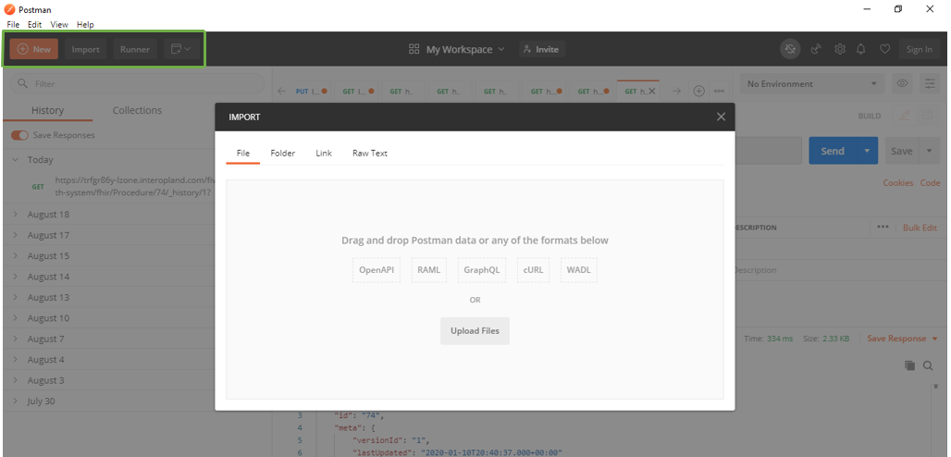

Step 4: Click on the Upload files button to upload the provided file called IOL FHIR API COLLECTION.

Step 5: Check to see that the collection appears in the **Collections tab** of your Postman app like this:

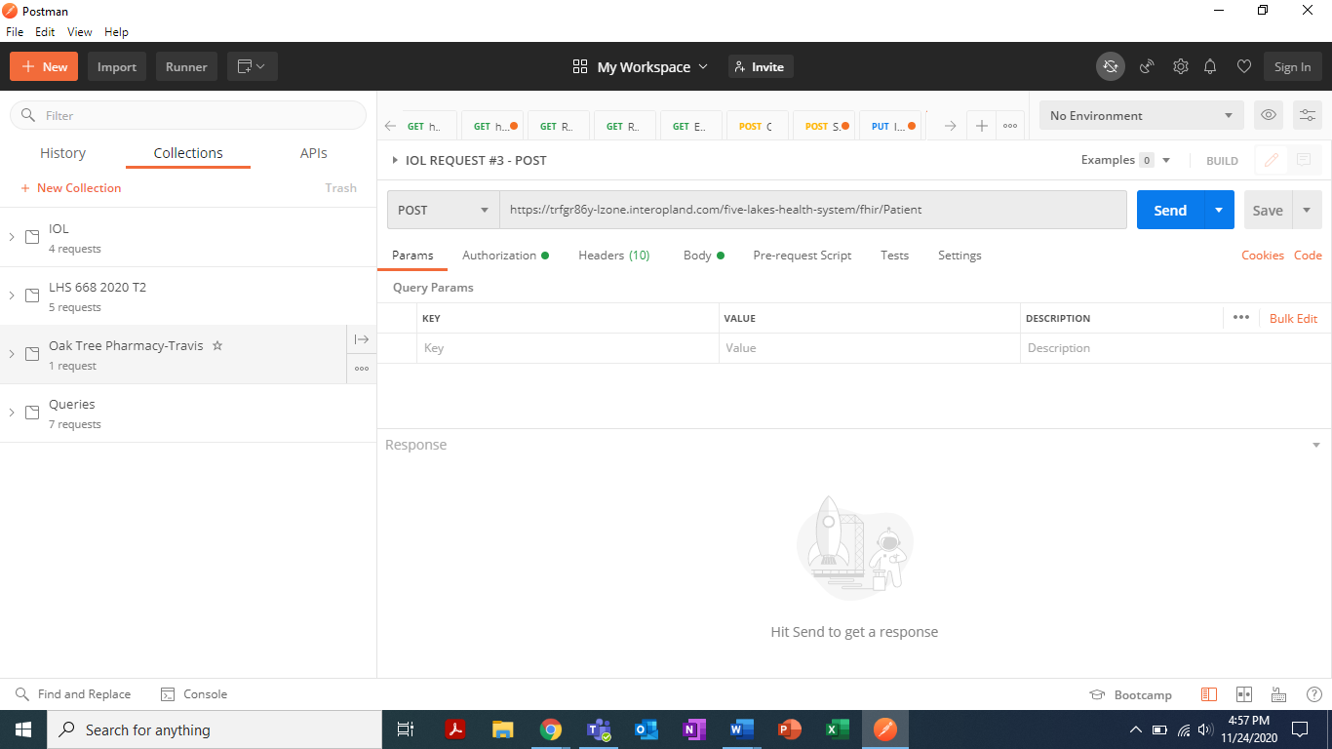

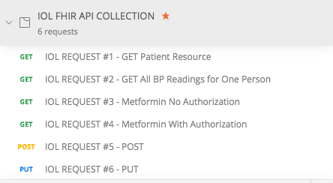

***That’s it!*** When you see the list of 6 requests above in Postman, you have the collection!

### **GETTING A PATIENT RESOURCE FROM THE FIVE LAKES HEALTH SYSTEM INTEROP PIT FHIR SEVER**

By connecting to InteroperabilityLand™ using Postman, next you will retrieve or GET a specific patient resource. We will now begin using the IOL FHIR API COLLECTION of API requests you imported into Postman. Follow these steps:

Step 1. From within Postman, click on “IOL Request #1- Get Patient Resource”



Step 2: Confirm that this URL appears in Postman’s User Interface:

<https://zj9zdg7t-lz3r.interopland.com/five-lakes-health-system/fhir/Patient?identifier=000003142>

The URL above links to the Five Lakes Health System FHIR server in InteroperabilityLand. The URL above specifies a request for the FHIR patient resource with the identifier = 000003142. This is how the FHIR API allows application programmers to quickly GET data!

Step 3: Click on the blue SEND button to GET this patient resource



Step 4: At the bottom of the screen, you should see that you have just retrieved a single FHIR patient resource for Suzanne Bulawayo. Part of her FHIR patient resource has an identifier section with the identifier used by the GET request. It that looks like this:

"identifier": [

{

"use": "official",

"type": {

"coding": [

{

"system": "http://hl7.org/fhir/identifier-type",

"code": "SB",

"display": "Social Beneficiary Identifier"

}

]

},

"system": "http://hl7.org/fhir/sid/us-ssn",

"value": "000003142"

### **QUESTIONS TO TEST YOUR KNOWLEDGE**

According to her Patient FHIR resource, what is Danny Soto’s BIRTHDATE?

**Your answer here**

### **GETTING ALL BLOOD PRESSURE OBSERVATION RESOURCES FOR ONE PATIENT FROM THE FIVE LAKES HEALTH SYSTEM INTEROP PIT FHIR SERVER.**

Next, we are going to use the FHIR API and InteroperabilityLand™ to get some observation data that could be used by a health app. In this case, our focus will be on getting data from past blood pressure readings. In FHIR, blood pressure (BP) readings are stored and conveyed using Observations type resources.

Step 1. From within Postman, click on “IOL Request #2- GET All BP Readings for One Person”



Step 2: Confirm that this URL appears in Postman’s User Interface:

<https://zj9zdg7t-lz3r.interopland.com/five-lakes-health-system/fhir/Observation?patient=4&component-code=8480-6&_format=json&_pretty=true>

The URL above links to the Five Lakes Health System FHIR server in InteroperabilityLand. The URL above specifies a request for the FHIR patient resources for patient 4 that ALSO HAVE a component-code of 8480-6.

What is component-code 8480-6? In the LOINC terminology, the code 8480-6 is a code for Systolic Blood Pressure. So, this is a search for all instances of FHIR resources for patient 4 with a COMPONENT or part of the resource that has this code.

Step 3: Click on the blue SEND button to GET the blood pressure information in Postman using the FHIR API



Step 4: At the bottom of the screen, you should see that you have just retrieved all the Observation resources for patient 4 that contain component code 8480-6. You should have retrieved 48 different Observation resources in a FHIR bundle.

“resourceType”: “Bundle”,

“id”: “e6360e78-9628-4a5a-b9e3-2e28ad8e8f6b”,

“meta”: {

“lastUpdated”: “2020-11-09T11:07:07.470+00:00”

},

“type”: “searchset”,

“total”: 48,

### **QUESTIONS TO TEST YOUR KNOWLEDGE**

1. Who is patient 4?

**Your answer here**

1. What are the results of patient 4’s blood pressure first 2 readings (systolic and diastolic blood pressure) IN CHRONOLOGICAL ORDER? (Note: Check the effective date and time and be aware that some observations may be dated in the future!)

**Your answer here**

1. In addition to blood pressure readings, what are some other facts about patient 4 are included in these 48 Vital Sign FHIR Observation resources?

**Your answer here**

1. What are some reasons that health consumer app developers might want to be able to GET Vital Signs information from other sources for use in their apps?

### **UNDERSTANDING BASIC AUTHORIZATION FOR FHIR APIs.**

Next, we will explore how Basic Authorization (i.e., login and password) function for the FHIR API provided by InteroperabilityLand™.

Step 1. From within Postman, click on “IOL Request #3- Metformin No Authorization”

Step 2: Confirm that this URL appears in Postman’s User Interface:

<https://zj9zdg7t-lz3r.interopland.com/oak-tree-pharmacy/fhir/Medication?code=860975&_pretty=true>

Step 3: Click on the blue SEND button

Step 4: You should see this response from the InteroperabilityLand FHIR API for the Oak Tree Pharmacy:

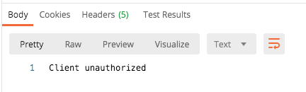

***Your request was denied!*** What happened?

Step 5: Click on ‘Authorization’ under the URL. You’ll see this:

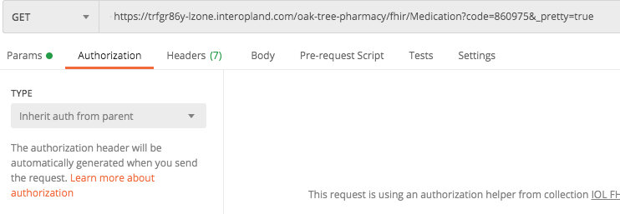

**Note:** No authorization is configured. Let’s try again with another, similar request.

Step 6. From within Postman, now click on “IOL Request #4- Metformin With Authorization”



Step 7: Confirm that this URL appears in Postman’s User Interface:

<https://zj9zdg7t-lz3r.interopland.com/oak-tree-pharmacy/fhir/Medication?code=860975&_pretty=true>

**Note:** This URL is the same as above in Part [D] Step 2!

Step 9: Click on the blue SEND button

Step 10: Confirm you received a FHIR medication resource for Metformin

"system": "http://www.nlm.nih.gov/research/umls/rxnorm",

"code": "860975",

"display": "24 HR Metformin hydrochloride 500 MG Extended Release Oral Tablet"

Step 11: Click again on ‘Authorization’ under the URL. You should see this:

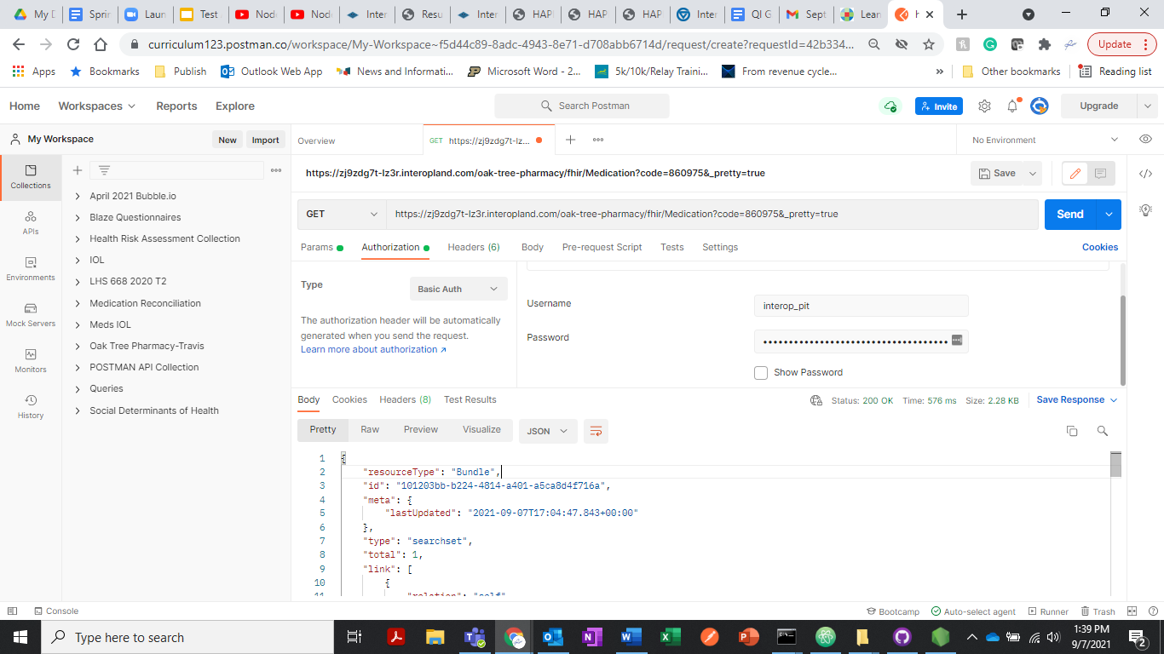

Notice the Username (interop_pit) and the password. These came from InteroperabilityLand™ for the Oak Tree Pharmacy.

Step 12: **Login to InteroperabilityLand** at interopland.com. Enter the Learning Zone 3 sandbox. Go to the Oak Tree Pharmacy. You will see a portion of the URL above and the Username and Password that we used in Postman here:

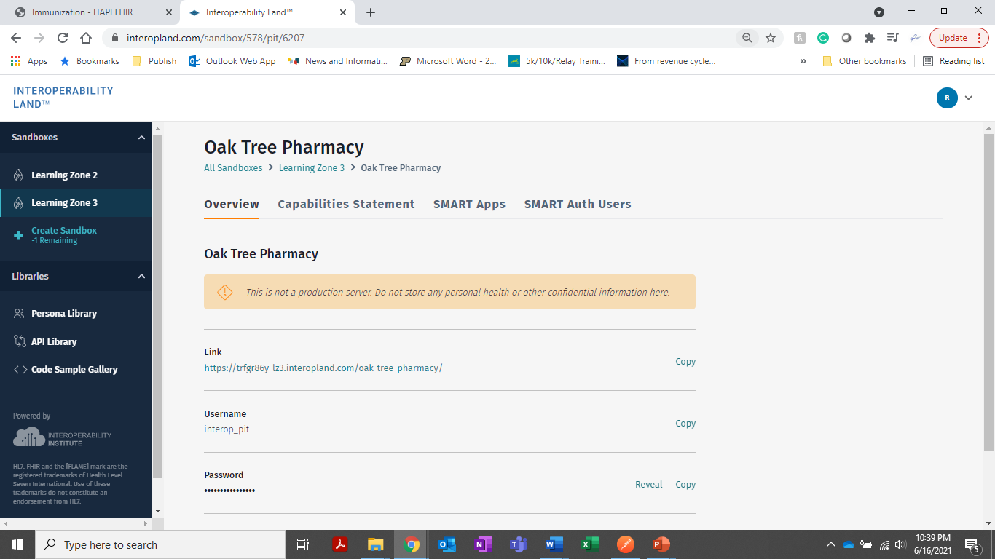

### **QUESTIONS TO TEST YOUR KNOWLEDGE**

1. From within InteroperabilityLand, what is the Link or URL to the SilverCaid server? (Hint: Explore the Learning Zone 3 sandbox and find SilverCaid.)

**Your answer here**

1. Do you think Basic Authorization with login names and passwords is enough for securing FHIR APIs? Why or why not?

**Your answer here**

### **ADDING A NEW PATIENT RESOURCE AND RECORD TO A FHIR SERVER USING THE FHIR API**

Step 1. From within Postman, click on “IOL Request #5- POST”

Step 2: Confirm that this URL appears in Postman’s User Interface:

https://zj9zdg7t-lz3r.interopland.com/five-lakes-health-system/fhir/Patient

Step 3: Click on the blue SEND button



Step 4: You should see this at the top of your response to pushing Send in Postman:

{

"resourceType": "Patient",

"id": "99999",

"meta": {

"versionId": "1",

"lastUpdated": "2020-11-09T11:51:59.479+00:00"

},

"text": {

"status": "generated",

This tells you that you successfully generated a NEW patient record by posting a single Patient FHIR resource to the Five Lakes Health System server. But where is that Patient resource that you just posted?

Step 5: Click on ‘Body’ underneath the URL in Postman to see the Patient resource you just Posted:

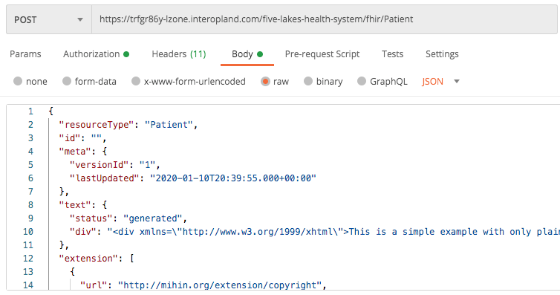

### **QUESTIONS TO TEST YOUR KNOWLEDGE**

1. What are the GIVEN and FAMILY names of the patient described by the FHIR Patient Resource that you POSTed to the Five Lakes Health System server using Postman and the FHIR API?

**Your answer here**

**TWO GENERAL QUESTIONS TO FINISH THIS SESSION**

1. What are some key differences between using the FHIR API to get information from a FHIR server and using the HAPI FHIR Server User Interface (as we did in Session 2)?

**Your answer here**

1. Why is it helpful to have LOINC or RxNORM codes in FHIR resources? How do those standards help us find information using the FHIR API?

**Your answer here**

### **OPTIONAL PART**

An additional FHIR API request called “IOL REQUEST #6 – PUT” is included in the IOL FHIR API COLLECTION.

A PUT resource CHANGES an existing FHIR resource in a FHIR server.

In this case, like in a POST, a Patient resource is in the BODY of the message coming from Postman.

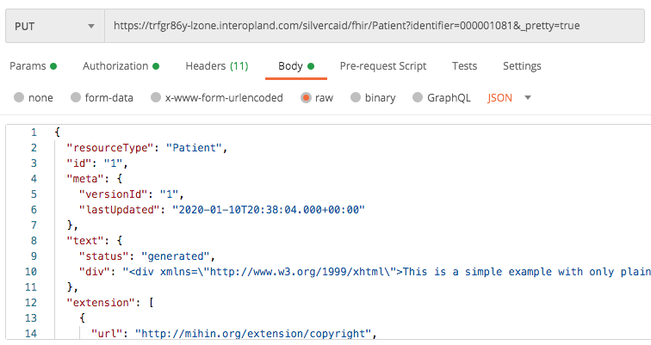

The fictitious Patient is Katherine M. Taylor.

EXTRA CHALLENGE: Using what you have learned about FHIR APIs and Postman, see if you can change one of Katherine M. Taylor’s phone numbers or her Postal Address in the SilverCaid FHIR server using this PUT command.